Pergunta 1

We can sort a list of numbers in ascending order by using the following recursive merge sort algorithm.
To sort a list of length n > 1:
- divide the list into two smaller lists of (approximately) half the length;
- recursively sort each of two halves;
- merge the two sorted results into a single list using the function merge() from NB18 ("Merging sorted lists").
When we reach lists of length 0 or 1 we can stop (because they are trivially already sorted).
Write a function msort(xs) that sorts a list xs of integers using this method. You cannot use the built-in function sorted or the list method sort.
Por exemplo:
Teste | Resultado
print(msort([3, 2, 1, 4])) | [1, 2, 3, 4]
print(msort([3, 3])) | [3, 3]
print(msort([7, 3, 1, 2, 4, 5, 6])) | [1, 2, 3, 4, 5, 6, 7]
print(msort([7, 3, 1, 2, 4, 5, 6, 3, 2, 5, 6, 1])) | [1, 1, 2, 2, 3, 3, 4, 5, 5, 6, 6, 7]

Pergunta 2
Write a Python function find_me(f, limits) that, given a function f and a tuple limits with two integers representing the search limits, returns how many iterations are necessary until the desired number is found.
The function f receives a number and returns either -1 (smaller) or +1 (bigger) or 0 (found). For example, f=lambda n: -1 if n > 30 else 1 if n < 30 else 0. That is, if we are searching for the number 30, then f(20) returns 1 (because 20 < 30), f(30) returns 0 (since 30 is the correct number!), and f(60) returns -1 (because 60 > 30).
You must start by guessing the middle number (that counts as an iteration) and use binary search to adjust the limits until the solution is found.
Por exemplo:
Teste | Resultado
print(find_me(lambda n: -1 if n > 30 else 1 if n < 30 else 0, (0, 100))) | 4
print(find_me(lambda n: -1 if n > 563 else 1 if n < 563 else 0, (-5000, 5000))) | 13
print(find_me(lambda n: -1 if n > -891 else 1 if n < -891 else 0, (-1000, 10000))) | 14
print(find_me(lambda n: 0 if n == 99 else 1, (0, 100))) | 6
Pergunta 3

Binary trees can be used to make it fast to search for ordered information. Each parent node can have two children nodes (left and right) in this data structure, which are also binary trees.
Consider the following binary tree:

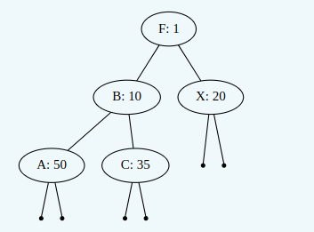

A binary tree is one of:
- None, representing an empty tree;
- a tuple of the form (key, value, left, right), where left and right are binary trees; the left tree keys are smaller than the parent key value, while the right tree keys are bigger than the parent key value.
Write a function search_tree(key, tree) that, given a string as key and the first node as tree, returns a pair (value, visited) or None if the key does not occur in the tree; the value is in the same tuple as key and visited is the list of keys that were visited in the search.
Hint: Take advantage of the binary structure of the tree to visit as few keys as possible.

Pergunta 4
Correta
Pontuou 20 de 20
Destacar pergunta
Consider a convex function f: ℝ → ℝ which maps a number into another number and is defined in the interval [0, 1]; for example:

Enunciado da pergunta

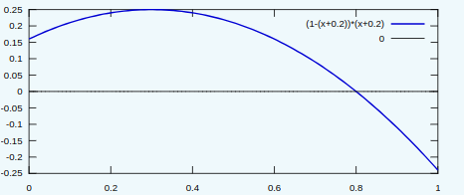

In this case, the root (zero) of a numeric function in the interval 0 to 1 can be found using the Bisection method (a type of binary search), as follows:
- Define the lower and upper bound variables as 0 and 1, respectively;
- Evaluate the function at the midpoint between the lower and upper bound;
- If f(lower) and f(midpoint) have the same sign, then lower := midpoint;
- Otherwise, upper := midpoint;
- Go back to 2 until n rounds have been performed;
- Return midpoint rounded to 5 digits
Write a Python function called bisect(f, n) that, given a function f and the number of rounds n, returns the root approximation at the nth round.
Por exemplo:
Teste | Resultado
print(bisect(lambda x: (1-(x+0.2))*(x+0.2), 10)) | 0.7998
print(bisect(lambda x: x**2-0.1, 8)) | 0.31641
print(bisect(lambda x: x**0.5-0.9, 10)) | 0.80957
print(bisect(lambda x: 2*x-20*x**2+1.5, 12)) | 0.32837
Pergunta 5

Write a Python function longest_prefix(words) that, given a non-empty list of words called words, returns the longest common prefix to all the words.
For example: If words=["apple", "apply", "ape", "april"], then the biggest prefix is "ap".
You should use the divide and conquer strategy to find out the longest prefix, as it is depicted in the figure bellow:
- if the list has one element, then the longest prefix is the element itself;
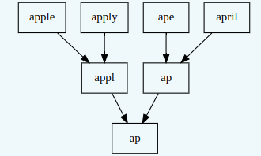
- for a list with two elements or more: divide the list into two halves, recursively find each half's common prefix and determine the two results' common prefix.
Hfgjds

Por exemplo:

Teste | Resultado
print(longest_prefix(['apple', 'apply', 'ape', 'april'])) | ap
print(longest_prefix(['geeksforgeeks', 'geeks', 'geek', 'geezer'])) | gee
print(longest_prefix(['sedatesingratiateconcomitant', 'sedatesparleypoliteness', 'sedateselbowsHahn', "sedatesgloweringimbecility's", 'sedatesbuttershexing', "sedatesKwangju'smulch's", 'sedatesunwiserN', 'sedatesprepossessedboggles', 'sedatesinterrelationshipdialings', "sedatesgropesNelsen's", 'sedatesMayfaircondemnations'])) | sedates
print(longest_prefix(['cahootsaffiliatedagglutinations', 'cahootslawnsrep', "cahootsSanka'sEwing", "cahootsdetection'simprovable", "cahootsVazquezChretien's", 'cahootsdevolvecrowded', 'cahootscudsdeterminant', 'cahootsfatheadhitches', 'cahootsthicknessesslow', "cahootssaying'soverreact", 'cahootsMethodistSherwood', 'cahootstackinessjourneyman', 'cahootsMoseleyreconsidering', "cahootspound'scondescendingly", 'cahootswellingtonhandsprings', "cahootsweekdayHussein's", "cahootsleitmotifssalmon's", 'cahootsgarrulitydefers', 'cahootsexplicitlyincapacitates', 'cahootsmaniafirst', 'cahootsgnomescosmetic', 'cahootselbowprotected']))

